Help System Documentation

Help Topics
The help system has a topics section where the shard developer can setup various topics to assist players. It is accessed from the first button in the help menu. You will notice that the shard name is displayed in the description for that button, in this example “The POL Distro” is setup as the shard name. Open \scripts\include\shardinfo.inc to change the shard name to your shard’s name.

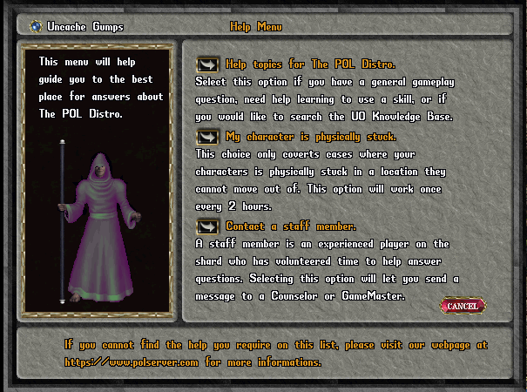
If you click on the topics button you will see a list of the currently defined topics. These are sample topics, many of them are incomplete with placeholders for information to be entered by shard administrators or developers. You will want to edit them for your shard. You can also add to the topic list.

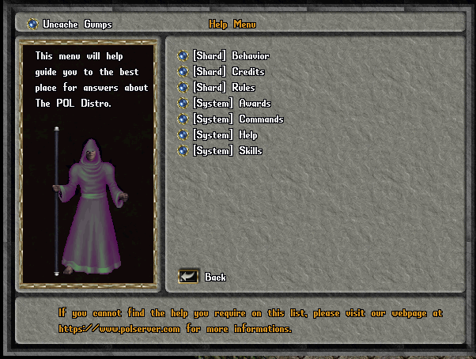
If you click on a button in the topic list, the gump will display the contents of a file associated with that topic. Here is the Credits topic.
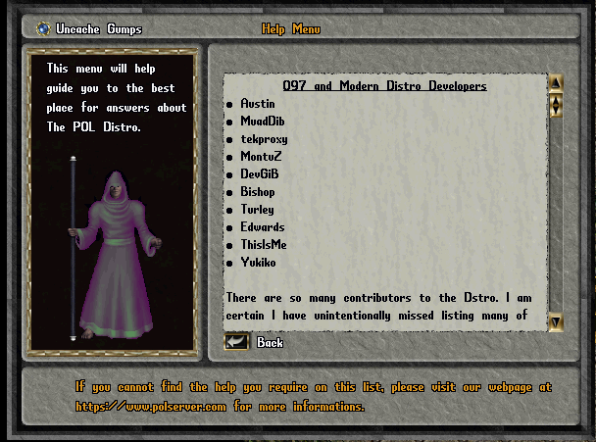

The topics files are located in \pkg\systems\help\helptopics. This is what the Credits file looks like if you open it in your editor:

<CENTER><U>097 and Modern Distro Developers</U></CENTER>

<B>o</B> Austin<BR>
<B>o</B> MuadDib<BR>
<B>o</B> tekproxy<BR>
<B>o</B> MontuZ<BR>
<B>o</B> DevGiB<BR>
<B>o</B> Bishop<BR>
<B>o</B> Turley<BR>
<B>o</B> Edwards<BR>
<B>o</B> ThisIsMe<BR>
<B>o</B> Yukiko<BR>
<br>There are so many contributors to the Dstro. I am certain I have unintentionally missed listing many of them.

In the gump, the help topics are displayed within an HTML gump element. When you edit or create the topic files, use HTML tags to format them properly.

The help topics list can be edited to add or remove topic items in the list. The topics list file is in \pkg\systems\help\config\helptopics.cfg. Here is the current contents of the helptopics.cfg file:

# $Id: helptopics.cfg 614 2006-07-06 15:23:38Z austinheilman $
#
#

Topic [Shard] Behavior
{
File behavior
}

Topic [Shard] Credits
{
File credits
}

Topic [Shard] Rules
{
File rules
}

Topic [System] Awards
{
File awards
}

Topic [System] Commands
{
File commands
}

Topic [System] Help
{
File help
}

Topic [System] Skills
{
File skills
}

Stuck Player
Occasionally a player may get stuck and unable to move. On some shards this would require the player to page a staff member and wait for a response. If no staff are online, this would delay help for the player. Using this help system, the second item in the main help menu provides a way for the player to become unstuck without the need for staff intervention. Clicking on the second option will present the player with the gump on the left. Clicking on a facet in that gump will display the gump on the right, listing the moongates in that facet. This allows the player to teleport from the current location where they are stuck to a moon gate in a facet of their choice.

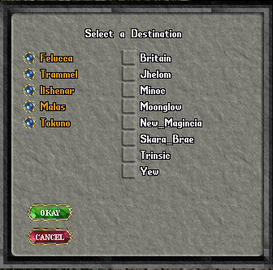
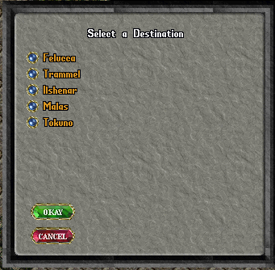

After choosing the moon gate, the player will receive a message that they will be teleported within 5 minutes. This delay prevents the player from cheating by using the “I am stuck” option to make a hasty escape from a fight or some other hostile situation. After the player is teleported to a moon gate using this option he or she will not be able to use the “I am stuck” help option for two hours. The “player stuck” option works with the jail keeper system to prevent jailed players from using it to break out of jail.

The Help Queue
When a staff member of seer level or higher logs in, the help queue gump will appear. This gump allows staff to respond to help requests that might have been made but are still awaiting a response from staff. Typing the command .helpqueue will also bring up the help queue gump.

Here is an example of the help queue gump where a player thinks he found a bug:
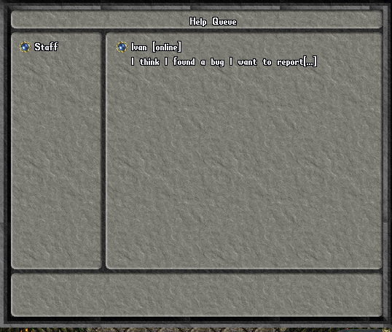

If the button next to the player’s name is clicked you will be presented with options in the lower section of the gump as well as the complete message.
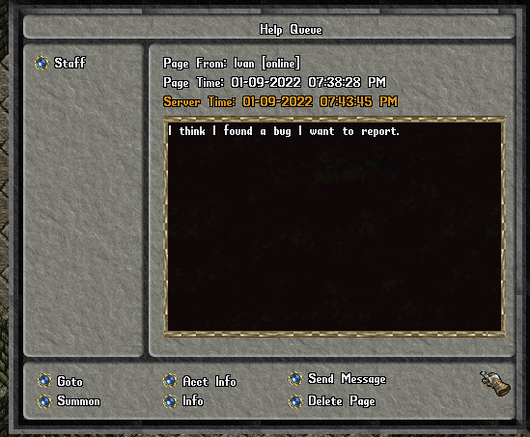

You can go to the character, summon the character to your location, review the player’s account information, activate the info command to review the character’s info, send a message to the character, or delete the page. Most of those options are self-explanatory but a little explanation is necessary regarding the message option. When you message the character, the character can send a one-time response. This option is not a chat system. There are enough third party chat systems that can be used for extended conversations and they are much more flexible and feature rich than could be written for in-game use.

